Co-Curricular College Activities July-2022 to June-2023:
July 2022
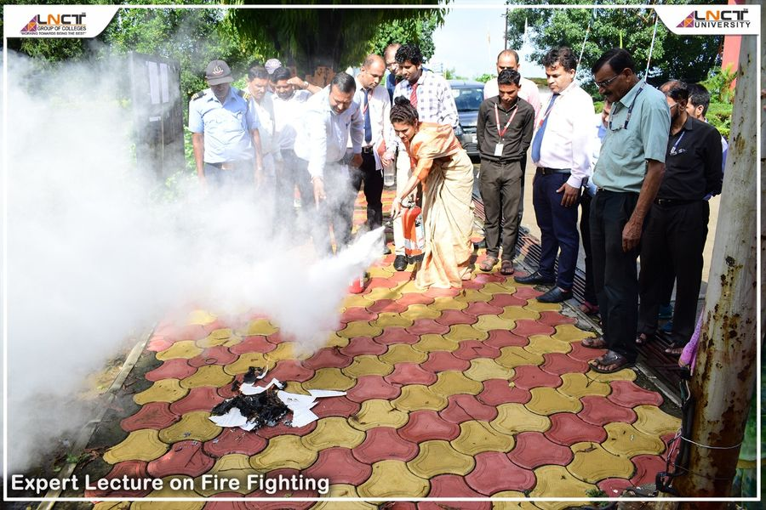
Glimpses of Expert Lecture on Fire Fighting #LNCTE
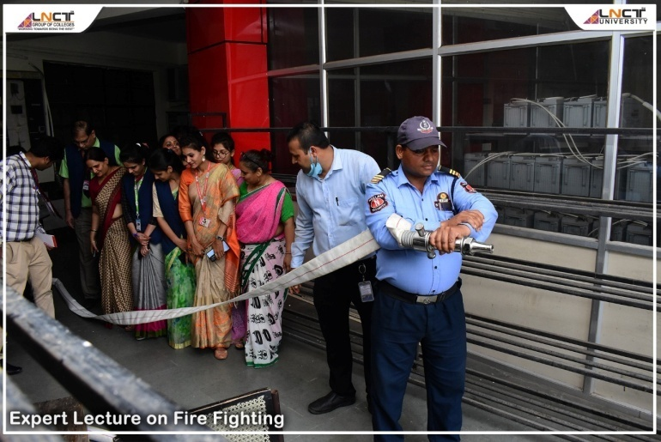

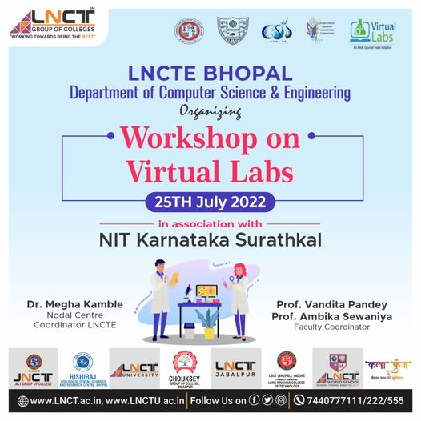
Workshop on Virtual Labs in Association with NIT Karnataka Surathkal!!

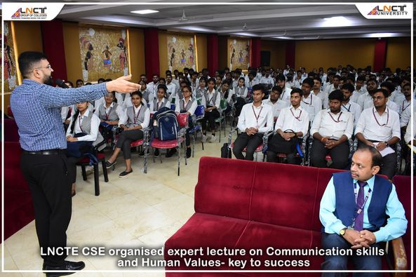
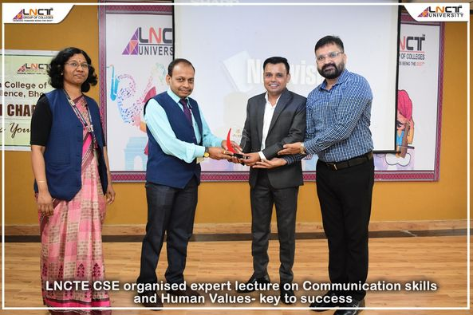
LNCTE CSE Organised an Expert lecture on Communication Skills and Human Values- key to success !!
August 2022
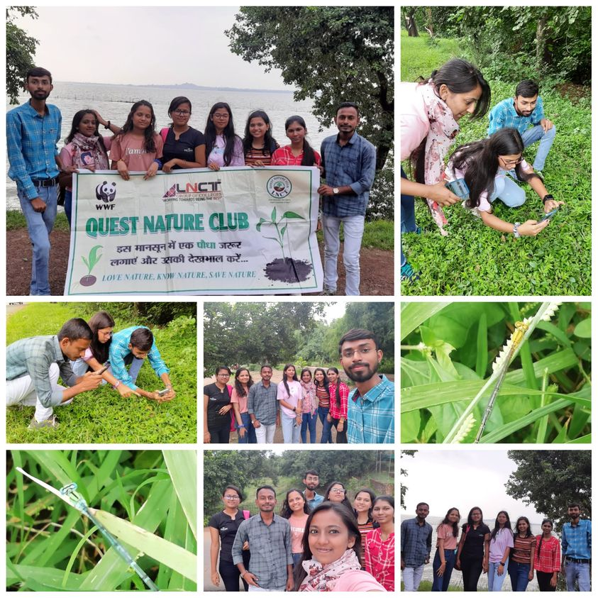
Members of QNC (Quest Nature Club , LNCT GROUP : LNCTE registered with WWF have participated in DFF 22 ( Dragonfly Festival 2022) orientation & wetland bio -monitoring visit at Van Vihar National Park (Bhoj Wetland) organized by WWF-MP&CG on 28-8-22.

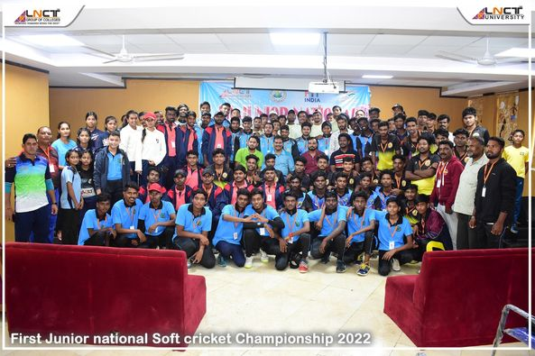
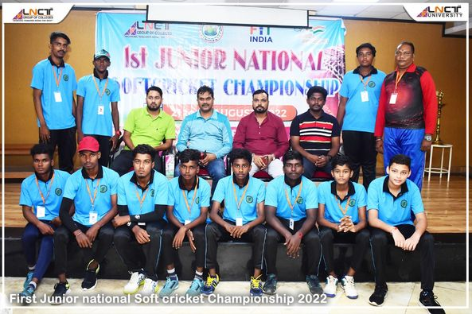
First Junior National Soft Cricket Championship Team 2022 !! #LNCTE

On the occasion of Azadi ka Amrit Mahotsav Department of Electronics & Communication Engineering, LNCT GROUP organized a poster making competition on 13/8/2022 Theme "INDIA AS A REPUBLIC"...... Total 40 students were participated in this competition #LNCTE

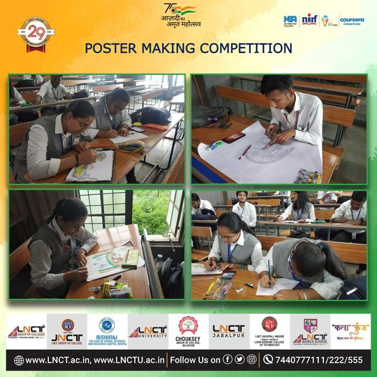
September 2022
LNCT Spic Macay & LNCT Spices Club Presents Bansuri Performance by Shri Rajesh Chaurasia !! Come and join us at LNCT&S Seminar Hall | 9 Sept 2022 #LNCTE
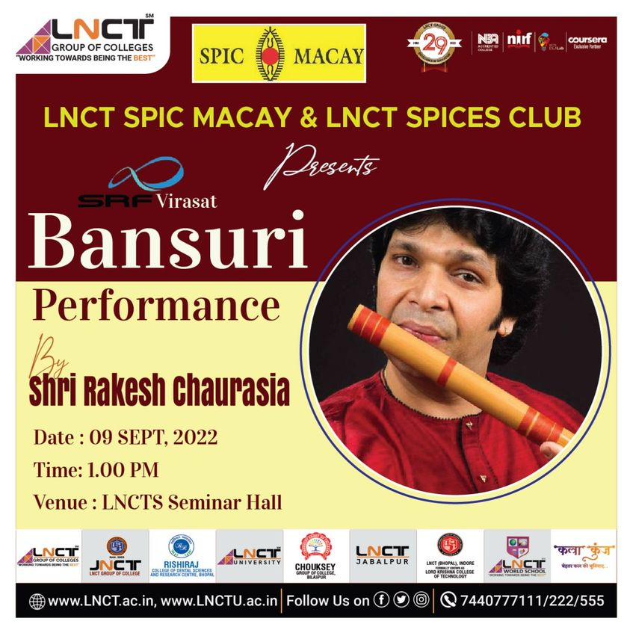

Department of Computer Science and Engineering, LNCTE Bhopal. Conducted Programming skills Quiz under ISTE Student Chapter " Check your programming skills " (MCQ Quiz contest) with software developed by CS 5th sem students Bhuvnesh and Devansh
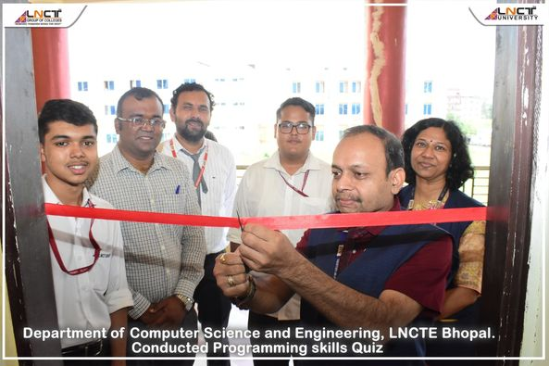
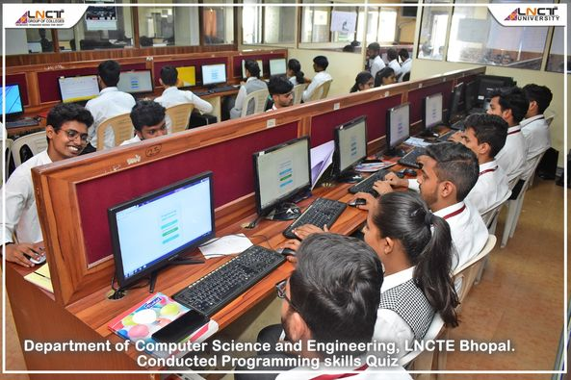
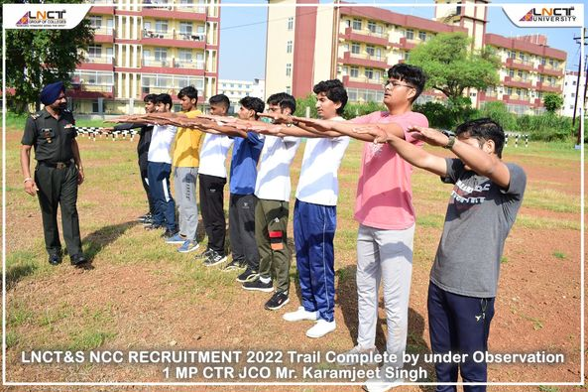
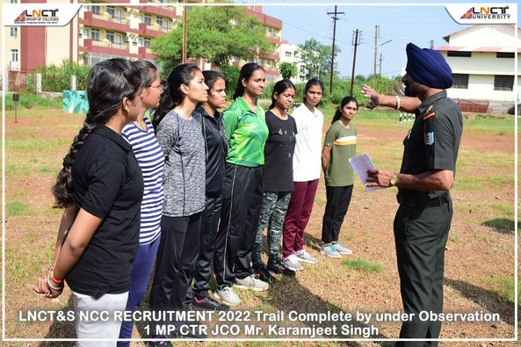
Glimpses of NCC Recruitment 2022 !!

Glimpses of Department of Electronics & Communication is Organized On the occasion of Engineers day the "Quiz Competition” !! #LNCTE
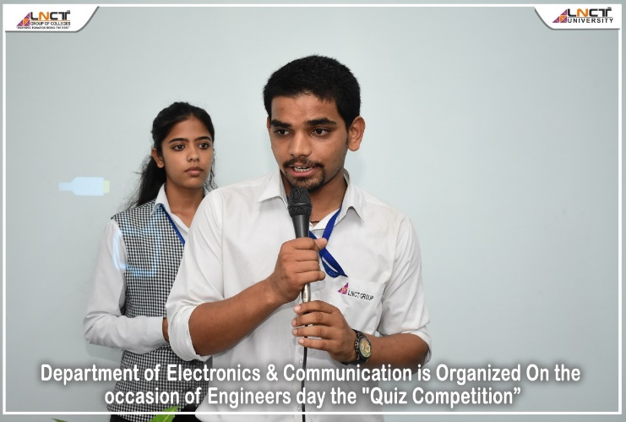
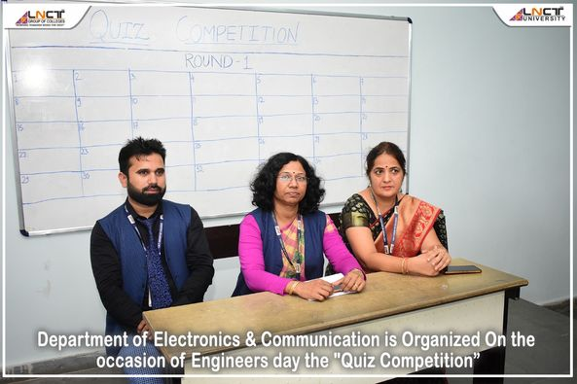

October 2022
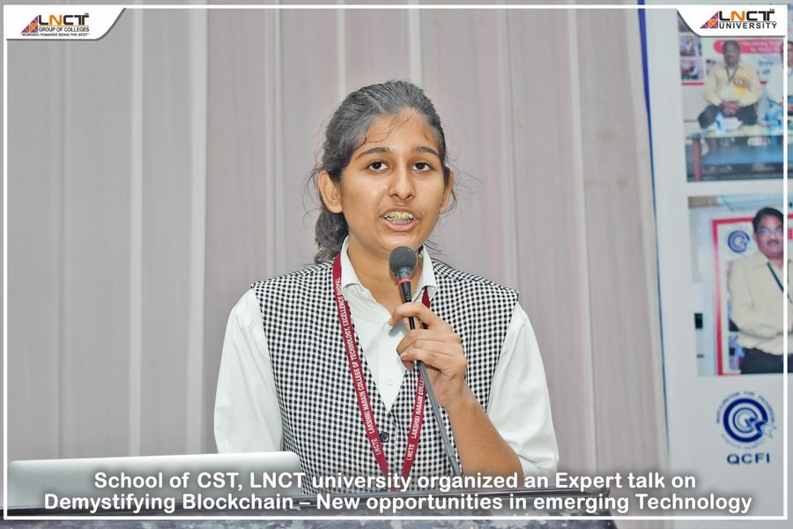
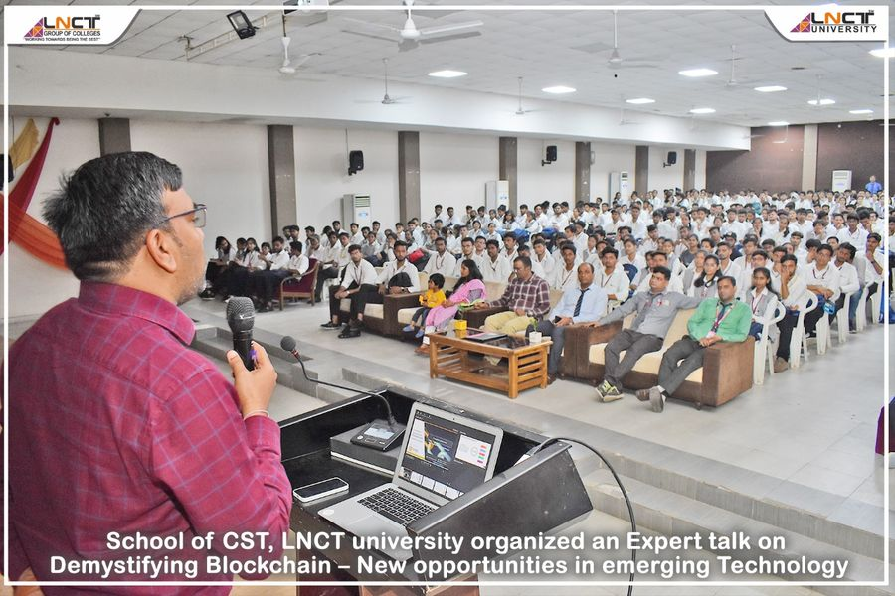
Expert Lecture on Demystifying Blockchain – New opportunities in emerging Technology !!

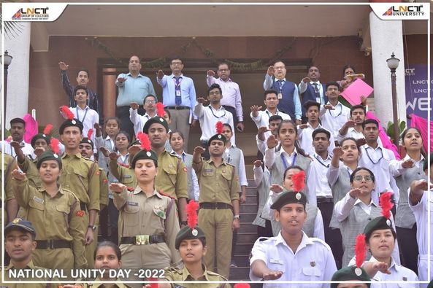
National Unity Day 2022: National Unity Day celebrated with great zeal and enthusiasm at LNCT Group of Colleges!! #LNCTE
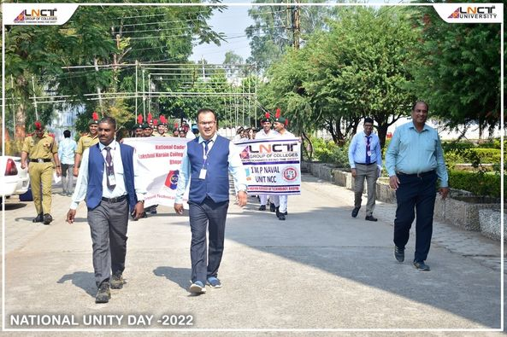
November 2022
Glimpses of ISRO Exhibition Valedictory at LNCT Bhopal campus !!
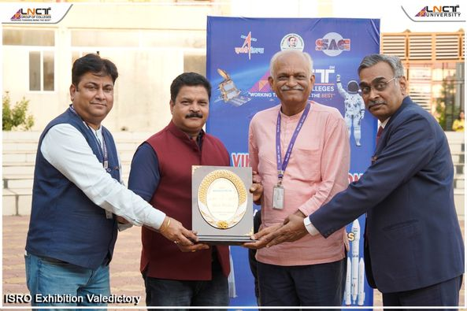
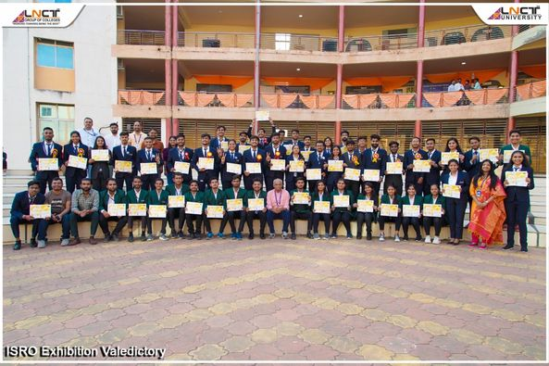
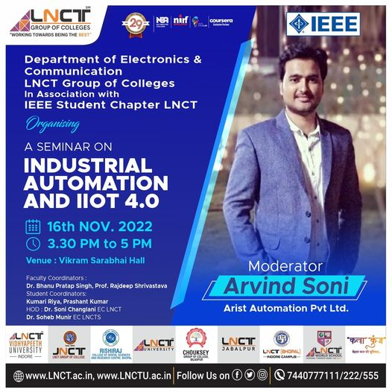
Department of Electronics & Communication LNCT group of Colleges in association with IEEE Student Chapter LNCT is going to organising a seminar on “Industrial automation and IIOT 4.0”

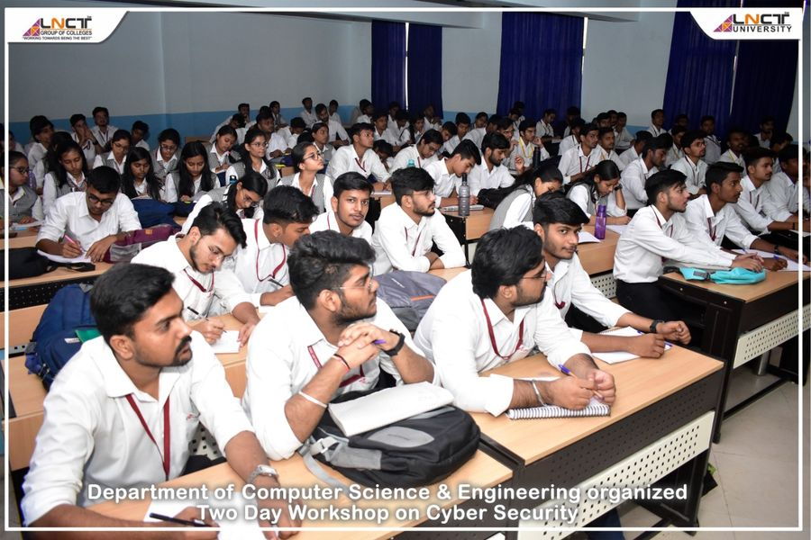
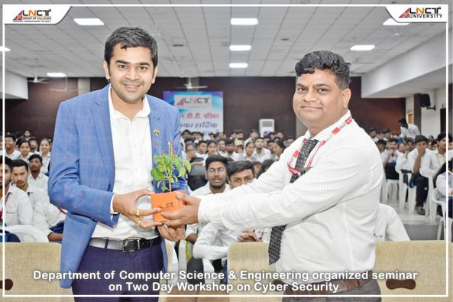
Glimpses of Workshop in Cyber Security !! #LNCTE
December 2022
#LNCTGroup, Training & Placement Department organised for its #students ‘A LIVE MUSIC CONCERT’ by famous young #singer & #youtuber Aryan Mudgal. Aryan who is an #engineering graduate himself enthralled everyone through his soulful voice and #inspired students to pursue and balance their #academics along with their #passion. Check some glimpses from the show.
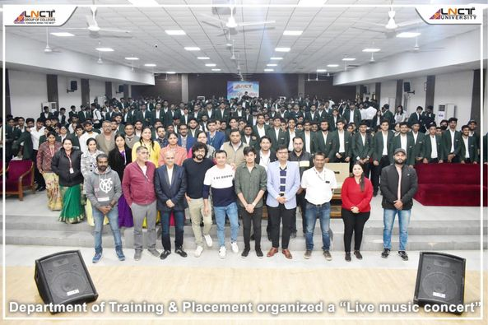

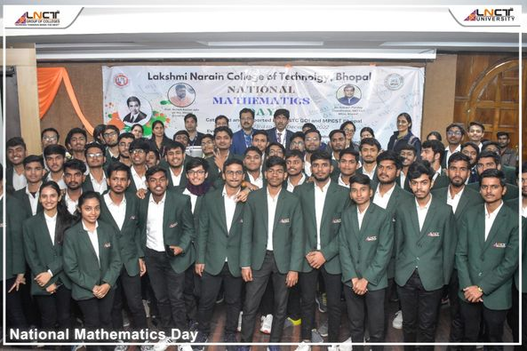
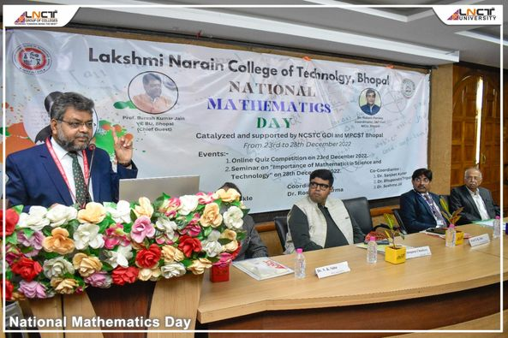
Glimpses of Seminar on "Importance of Mathematics in Science & Technology" !!#LNCTE

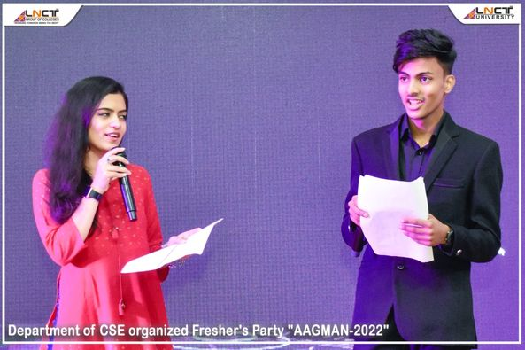
Glimpses of "AAGMAN-2022" - Fresher's Party was a blast !! Fresher's Party is a happening of fun, frolic and fun! #LNCTE

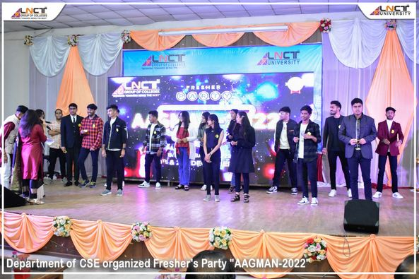
January 2023
Patriotic Run Organised by LNCTE as a part of Republic Day celebration. It is an initiative of Veterans India in Collaboration With AICTE and Recognised by Fit India " Rashtra Bhakti - Khel se Shakti ". The run received overwhelming response .Over 1200 students and teachers enthusiastically participated in this rally.Tha objective of run is to enhance the feeling of Nationalism and Patriotism among students and staff of the institutes.
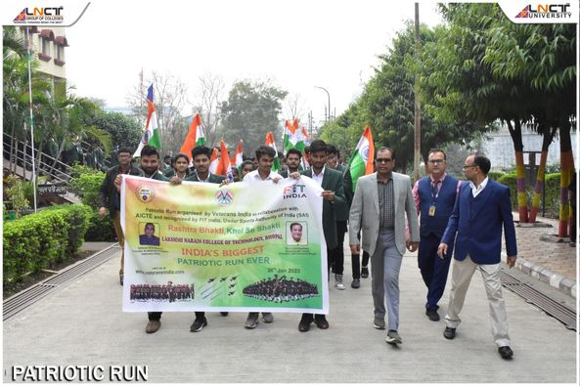
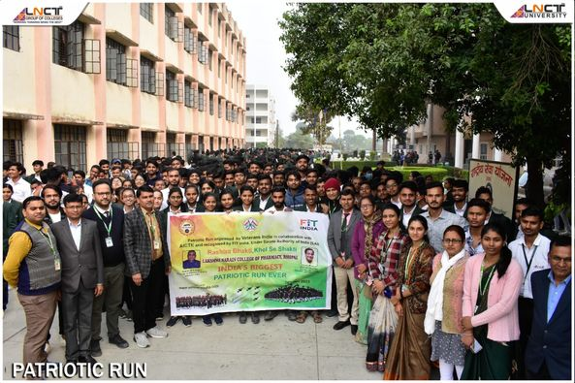

The IIC of LNCTE organized Poster Making competition to celebrate "National Youth Day 2023" and to commemorate 160th Birth Anniversary of Swami Vivekananda Ji
A total number of 55 participants from different colleges of LNCT GROUP (LNCTE participated in the event with great enthusiasm and zeal. They beautifully presented their idea on the theme Youth's Contributions to Society through their posters.

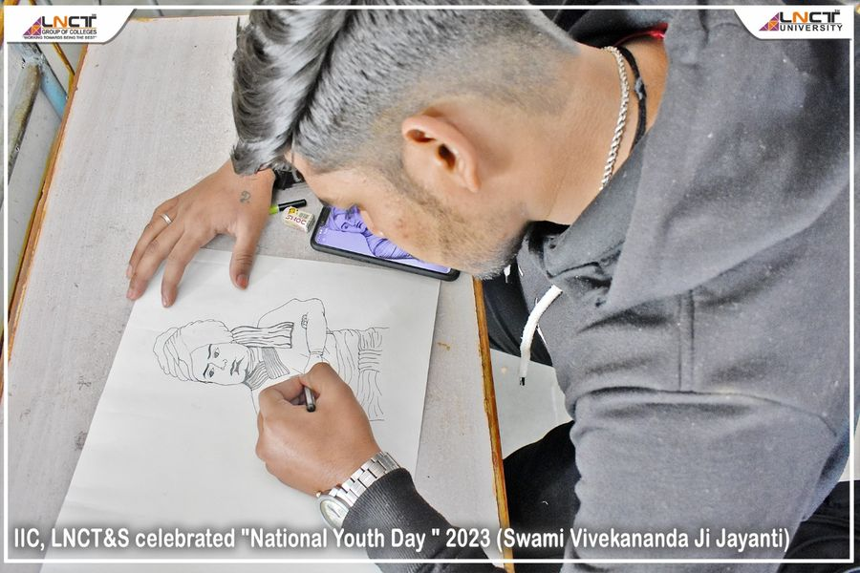

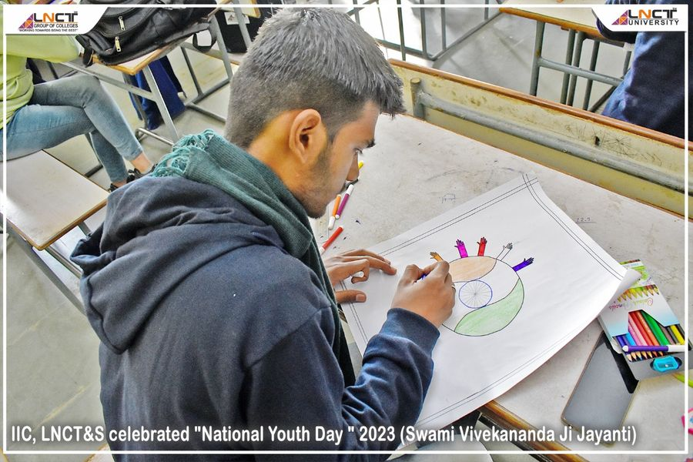
February 2023
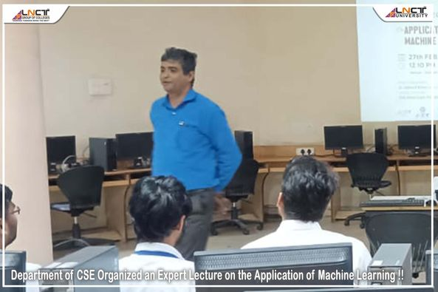
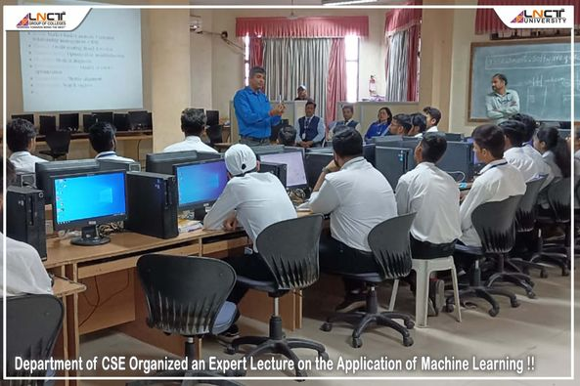
Glimpses of Department of CSE Organized an Expert Lecture on the Application of Machine Learning !! # LNCTE

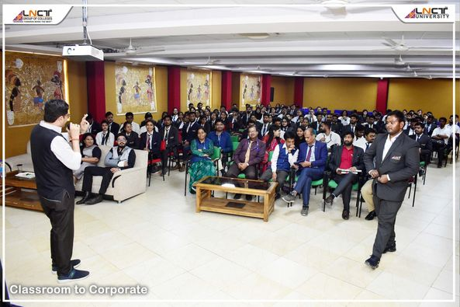
An interactive and engaging session on “Classroom to Corporate“ !! #LNCTE
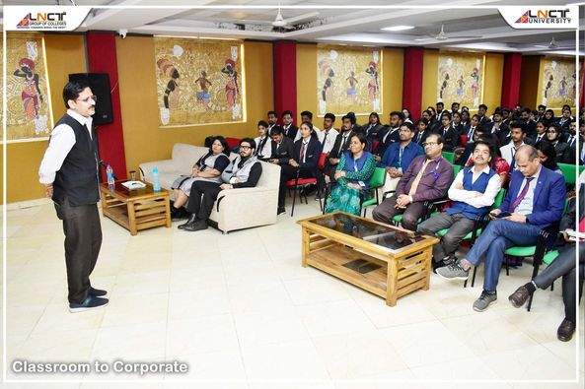
March 2023
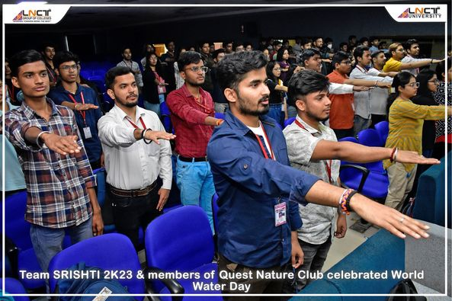
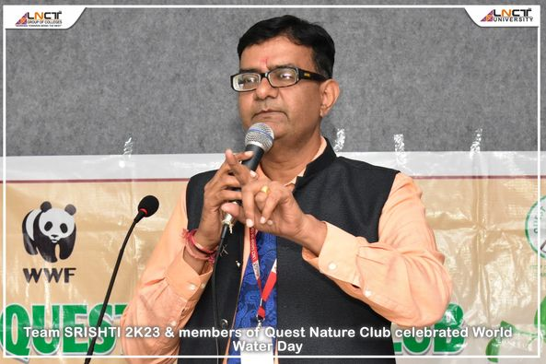
Happy World Water Day everyone! Today, we're proud to celebrate alongside Team SRISHTI 2K23 and members of Quest Nature Club, who are taking action to promote sustainable water management and protect our planet's freshwater resources. Let's all do our part to conserve water and make positive changes for our environment. #LNCTE

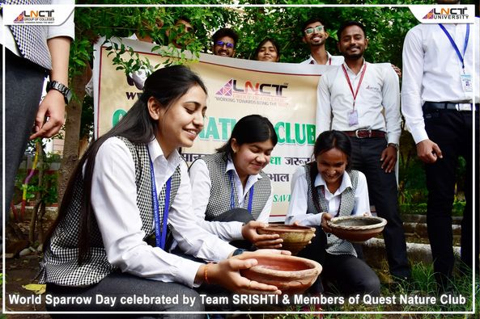
Team SRISHTI and members of Quest Nature Club came together to celebrate World Sparrow Day! It was a great opportunity to raise awareness about the conservation of these beautiful birds and the importance of protecting their habitats. #LNCTE
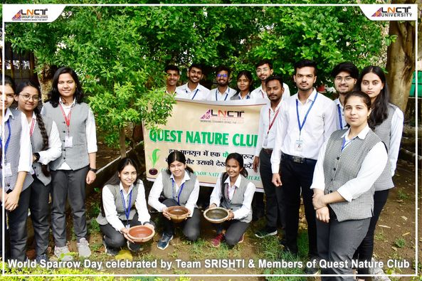
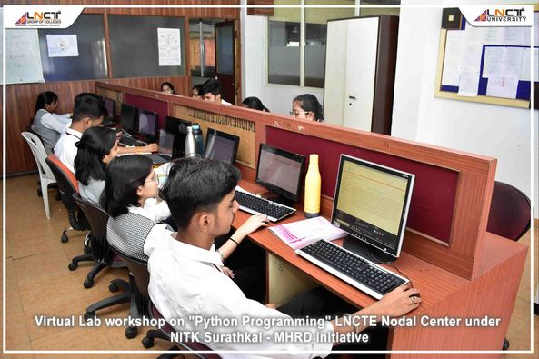
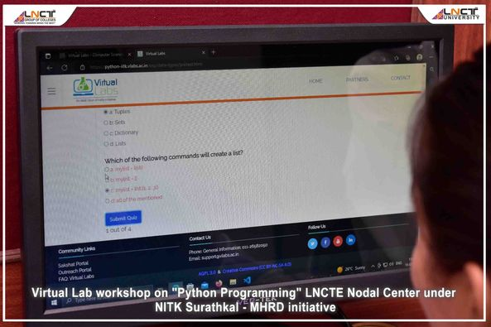
The LNCTE Nodal Center under NITK Surathkal - MHRD initiative is organizing a virtual lab workshop on "Python Programming" for students and faculty members of LNCTE.

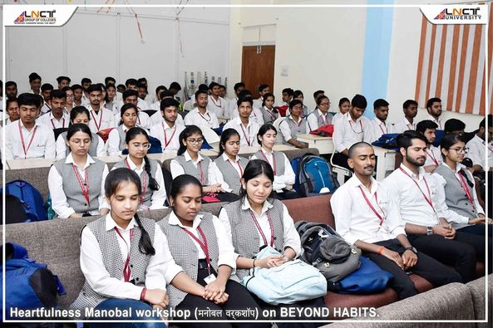
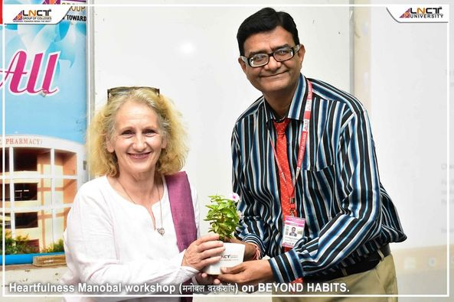
Heartfulness Manobal workshop (मनोबल वर्कशॉप) on BEYOND HABITS organized at LNCTE, LNCT management had invited Heartfulness Manobal Kendra today to conduct a session on " Beyond Habits" at LNCT Raisen Riad Campus for the benefit of our students. Mrs Lynn Gedess of Scottland and Mrs Revathi Suresh of Chennai addressed the students and informed of various support systems and techniques to fight against problematic habits faced by the students.

एलएनसीटीई,भोपाल की राष्ट्रीय सेवा योजना इकाई के सात दिवसीय विशेष शिविर का शुभारंभ 12 मार्च को किया गया ,जो कि ग्राम कोलुआ जिला भोपाल में लगाया गया। उपरोक्त शिविर में विद्यार्थियों द्वारा ग्रामीण जन को नुक्कड़ नाटक द्वारा स्वच्छ्ता, साक्षरता, उन्नत भारत, बेटी बचाओ बेटी पढ़ाओ, डिजिटल इंडिया के बारे में घर-घर जाकर जानकारी, विद्यार्थियों द्वारा गांव में रैली निकाल कर एवं नुक्कड़ नाटक कर ग्रामीणों हेतु जागरुकता कार्यक्रम किये जा रहे हैं। शिविर के शुभारंभ के अवसर पर महाविद्यालय के डॉ अनुपम चौकसे एक्जेक्यूटिव सेक्रेटरी एलएनसीटी समूह , डॉ अशोक कुमार राय डायरेक्टर एडमिनिस्ट्रेशन एलएनसीटी, ने शिविरार्थियो को शिविर हेतु प्रोत्साहित किया एवं शिविर के सफल आयोजन हेतु शुभकामनाएं दी।
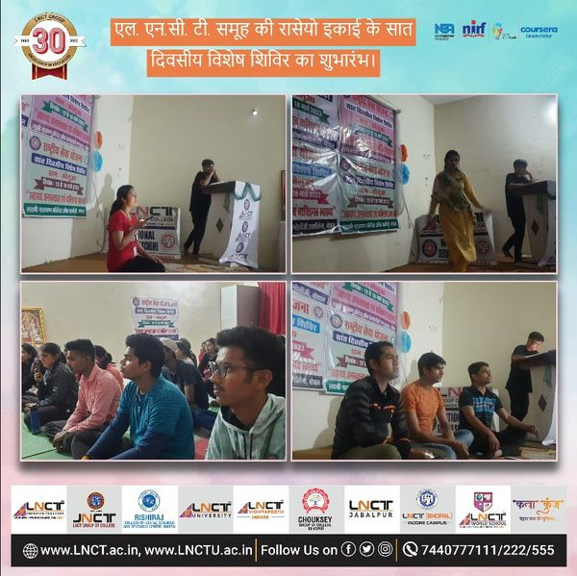

One Plant a Day !!

मुख्यमंत्री जी द्वारा प्रतिदिन पेड़ लगाने की अनुपम पहल में सम्मिलित हुआ एलएनसिटी समूह. आज मुख्यमंत्री शिवराज सिंह चौहान के साथ एलएनसिटी समूह के सेक्रेटरी डॉ. अनुपम चौकसे जी एवम एलएनसीटी विद्यापीठ यूनिवर्सिटी की प्रो चांसलर डॉ. श्वेता चौकसे ने मुख्यमंत्री के साथ स्मार्ट सिटी पार्क में पीपल का पौधा रोपण किया। पर्यावरण के संरक्षण, संवर्धन के लिए आपकी यह प्रेरणादायी पहल निश्चित रूप से अभिनंदनीय है।
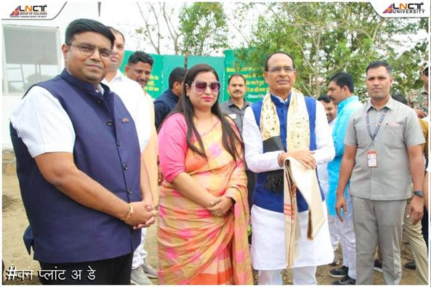
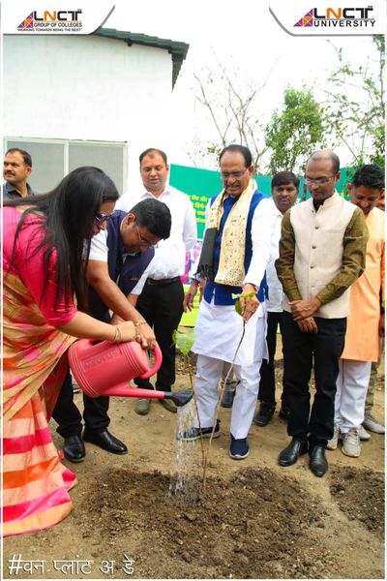

एलएनसीटीई, भोपाल की राष्ट्रीय सेवा योजना इकाई के सात दिवसीय विशेष शिविर का समापन समारोह 18 मार्च को संपन्न हुआ, जो कि दिनांक 12 मार्च से 18 मार्च 2023 तक ग्राम कोलुआ,जिला भोपाल में लगाया गया था। उपरोक्त शिविर में विद्यार्थियों द्वारा ग्रामीण जन को नुक्कड़ नाटक द्वारा स्वच्छ्ता, साक्षरता, उन्नत भारत, बेटी बचाओ बेटी पढ़ाओ, डिजिटल इंडिया एवं कोरोना वायरस से बचाव के बारे में घर-घर जाकर जानकारी दी। विद्यार्थियों द्वारा गांव में रैली निकाल कर एवं नुक्कड़ नाटक कर ग्रामीणों को आवश्यक जानकारी देकर जाग्रत किया। शिविर में कॉलेज के छात्र तथा छात्राओं ने उपस्थिति दर्ज कर अपने व्यक्तित्त्व का विकास किया। शिविर के अंतिम दिन समापन समारोह के अवसर पर डॉ अनुपम चौकसे प्रति कुलाधिपति एल एन सी टी विश्वविद्यालय भोपाल एवं कार्यकारी सचिव एल एन सी टी समूह भोपाल तथा डॉ अशोक कुमार राय निदेशक प्रशासनिक एल एन सी टी भोपाल ने शिविरार्थियो को प्रमाण पत्र प्रदान कर स्वयं सेवकों को प्रोत्साहित किया एवं उनके उज्जवल भविष्य की कामना की।
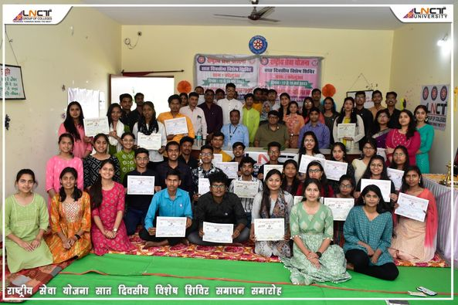
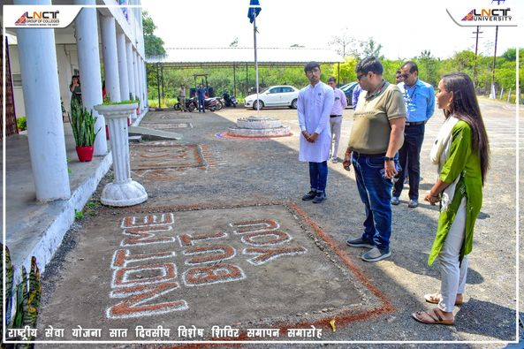
April 2023
World Earth Day: 'When we care for the Earth, we care for ourselves' Quest Nature Club, LNCT GROUP hold plantation drives, awareness sessions, competitions on the eve of World Earth Day , Students vow to protect ecology.From 1970 , Earth Day has been celebrated around the world to call attention to some of our most pressing environmental and social problems, including climate change, biodiversity loss, ozone layer depletion, global warming, pollutions
and dwindling natural resources. The day started with a beautiful message where students were reminded of 7 actions towards safe earth. Each one of them took a pledge to save Mother Earth by doing simple doable actions. Our continuing effort in our daily life will make this beautiful planet thrive. QNC,LNCT GROUP marked the World Earth Day with activities widespread to invoke respect, concern and action to conserve the natural resources. Moving with the theme- Invest in our planet, activities like in-campus plantation drive, Pledge, paper bags distribution organized. An Online Environmental awareness quiz will be organised on Earth Day.
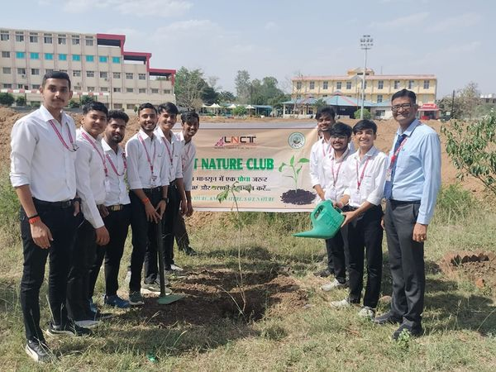
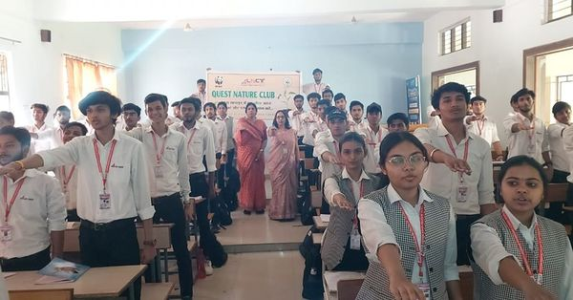
सृष्टि 2K23 के अंतर्गत आज एलएनसीटी समूह के स्टूडेंट्स ने भोपाल के विभिन्न क्षेत्रों में जाकर सिंगल यूज प्लास्टिक उत्पाद (Single - use plastic products) के दुष्प्रभाव समझाएं एवं सभी से कपड़े का थैला एवं पेपर बैग का उपयोग करने का आह्वान किया।
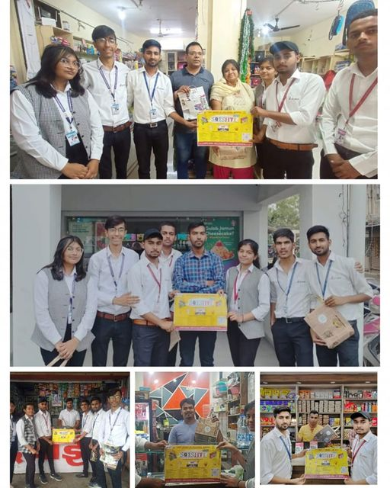

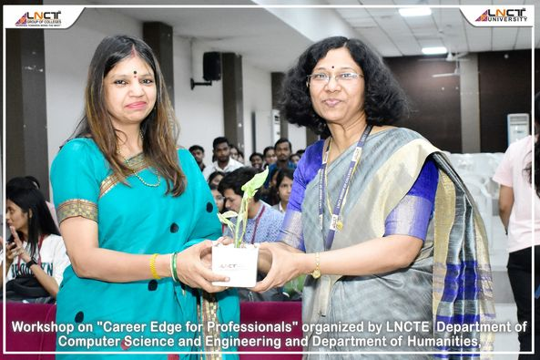
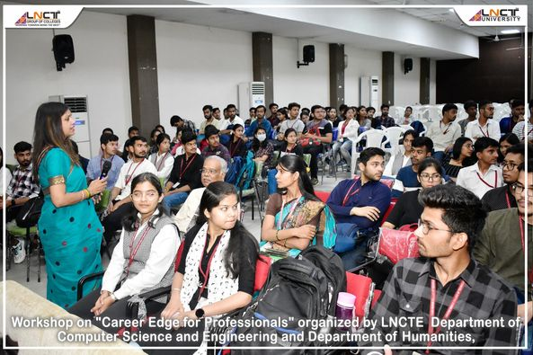
Workshop on "Career Edge for Professionals" organized by Lakshmi Narain College of Technology Excellence , Department of Computer Science and Engineering and Department of Humanities, Resourse Person, Dr.Anjana Tiwari, Professor, NITTTR Bhopal. 5th april 2023.
May 2023
मध्य प्रदेश की राजधानी भोपाल अपना स्थापना दिवस गौरव दिवस के रूप में मना रही है। ऐसे में पूरे सप्ताह कार्यक्रमों का आयोजन किया जाना है। जिसकी शुरुआत आज सुबह से ही मुख्यमंत्री शिवराज सिंह चौहान के गौरव यात्रा को फ्लैग ऑफ से हो गई है। भोपाल के गौरव दिवस को लेकर बोट क्लब पर वॉटर एडवेंचर का भी आयोजन किया गया !! भोपाल के गौरव दिवस के उत्सव में, एलएनसीटी ग्रुप ऑफ कॉलेज के छात्रों ने उत्साहपूर्वक हिस्सा लिया। इस अवसर पर, छात्रों ने वॉटर एडवेंचर आयोजन में भाग लेते हुए अपनी कौशल और साहस दिखाए। इस अनुभवपूर्ण कार्यक्रम में, वे नौका-विहार, जल-सफारी, और अन्य वाटर एक्टिविटीज का आनंद लिया।
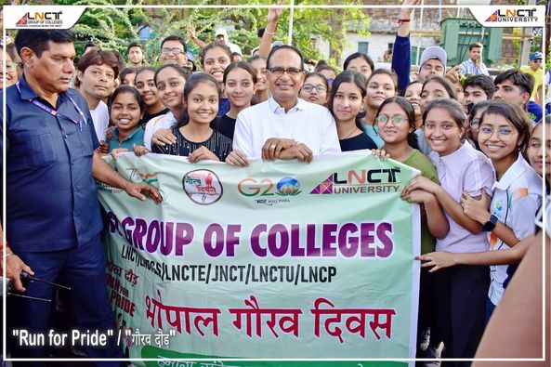
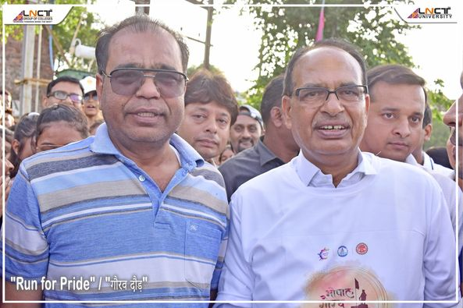

Take a look back at the amazing memories we've made with our Batch 2019-23 from the Computer Science department! From learning the latest programming languages to developing innovative projects, our Computer Science students have left an indelible mark on our institution. #LNCTE
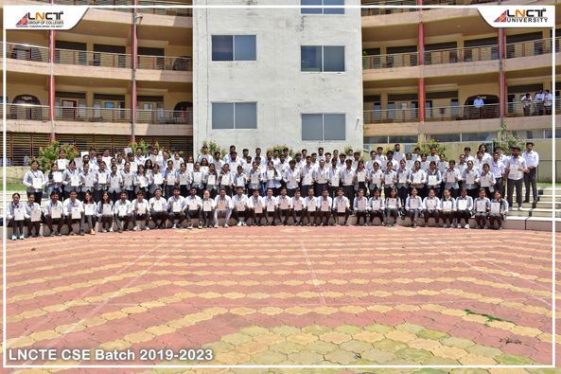

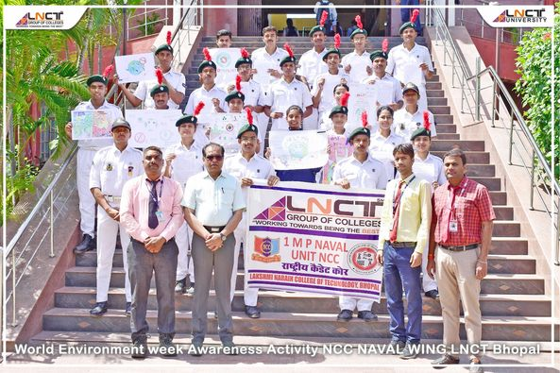
Preserving Our Precious Blue Planet NCC Naval Wing LNCT Bhopal Amplifies Awareness during World Environment Week! Discover the Inspiring Moments from this Green Initiative. #LNCTE
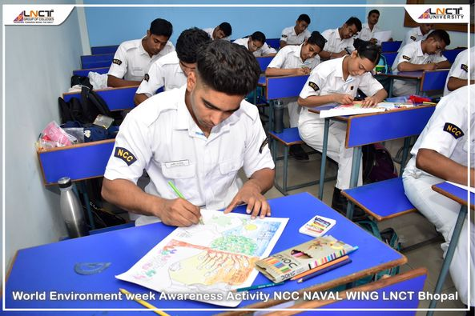

June 2023
LNCT Group of Colleges joyfully celebrated International Day of Yoga 2023, extending wishes for a healthy life for all! Faculty members, staff, and participants enthusiastically joined the Yoga session led by expert trainers. Today, Yoga has permeated every corner of the world, becoming India's emblem of soft power. Experience the transformative power of Yoga as it brings tranquility to the mind and revitalizes the body. Find solace in its practice. When we prioritize health and well-being, Yoga is at the forefront of our thoughts. It serves as preventive care, nurturing immunity within our bodies. Let's continue embracing Yoga's holistic benefits for a healthier and harmonious life!
